Image | 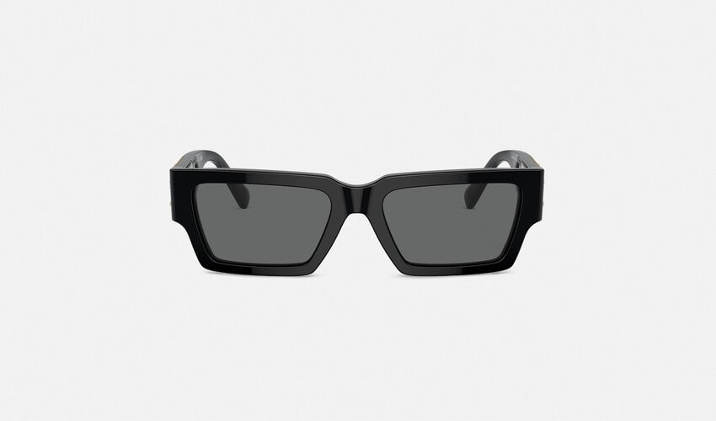
Brand | TOM FORD
Model Name | MEDUSA DECO SUNGLASSES
Price | RS 150,400
PRODUCT DETAILS

